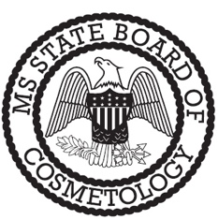
ESTHETICIAN
STUDENT CERTIFICATION OF RECEIPT

School Name / City
Enrollment Date |  | Start Date

Student Name | First | Middle | Last
Mailing Address | Street Address
 | City | State | Zip
Social Security Number
Telephone Number
I understand that I must have no less than a twelfth (12th) grade education or its equivalent in order to be approved to take the examination for licensure to become a practitioner.

I DO HEREBY CERTIFY THAT I HAVE RECEIVED EACH OF THE FOLLOWING UPON ENROLLMENT: | DATE RECEIVED
School Contract
School Rules and Regulations
Textbook (for the course program enrolled)
MS State Board of Cosmetology Rules and Regulations
Kit Containing the Minimum Equipment Required by the MS State Board of Cosmetology (Rule 5.17(a))

I DO HEREBY CERTIFY BY MY SIGNATURE BELOW THAT ALL THE INFORMATION ABOVE IS TRUE AND CORRECT TO THE BEST OF MY KNOWLEDGE.

______________________________________________ ________________________
Student Signature Date

______________________________________________ ________________________
Witness (School Agent or Instructor) Date

